McLendon Drive Water Transmission Main Replacement Project
Fact Sheet
Department of Watershed Management | DeKalb County, Georgia

What is the Project?
DeKalb County Department of Watershed Management (DWM) has requested Tetra Tech’s assistance in the
design of a new 42-inch water transmission main to replace the aged existing 42-inch prestressed concrete cylinder
pipe (PCCP). This project will also replace the distribution water mains within this corridor. The distribution main diameter varies from 8-inches to 12-inch. This project is part of the DWM’s Capital Improvement Program, PCCP Transmission Main Replacement Phase D.
The streets impacted include Tanner Drive, McLendon Drive, and several neighborhood roads between the intersections of Rehoboth Drive and Lawrenceville Highway (US Highway 29).
The section of the existing 42-inch transmission main being replaced extends from Church Street going north along Murphey Street, east on North Avenue, north on McLendon Drive, northeast on Lawrenceville Highway and terminates on Montreal Road.
The primary components include:
- Replacing and/or upgrading of approximately 13,000 linear feet (approximately 2.5 miles) of 42-inch water transmission main.
- Replacing and/or upgrading of approximately 19,000 linear feet (approximately 3.6 miles) of water distribution main ranging in diameters from 8 to 12 inches.
- Crossing underneath Highway 78 and Highway 29.
- Abandoning aged water infrastructure adjacent to propose water transmission mains.
The project is divided into two sections:
- New mains: From Church Street to North Ave, along McLendon Drive to south of Highway 78, along Tanner Dr, north of Hwy 78 to Hwy 29, Rehoboth Dr to Montreal Rd, neighborhood roads near Hwy 29
- Lining of existing pipe: Underneath Hwy 78.

Things You Need to Know
DeKalb County owns and operates an extensive potable water system through its Department of Watershed Management (DWM). The system serves more than 775,000 residents, produces up to 150 million gallons per day (MGD) of finished drinking water, distributes approximately 75 MGD to customers, and includes more than 5,200 miles of water distribution and sanitary sewer piping. The County’s water infrastructure includes a major drinking water treatment facility, transmission mains, distribution mains, pump stations, storage facilities, valves, hydrants, and approximately 250,000 customer service connections.

The County’s water system includes large-diameter transmission mains that convey treated water from the water treatment facility to pressure zones and service areas, as well as smaller distribution mains that deliver water to residences, businesses, and fire hydrants. Under the County’s 2020–2050 Water and Wastewater Master Plans, planned water system improvements include approximately 58 miles of 60-inch transmission mains, 8 miles of 30- and 36-inch transmission mains, 19 miles of 20- and 24-inch transmission mains, 17 miles of 16-inch transmission mains, and 34 miles of 8- and 12-inch mains. Approximately 300 miles of additional local hydraulic improvement mains are also planned to address fire-flow deficiencies.

Much of the County’s water infrastructure was installed several decades ago and requires ongoing rehabilitation, replacement, and capacity improvements. Aging and failure-prone transmission mains can experience breaks that interrupt service, damage roadways, affect traffic, and reduce system reliability. For example, the existing 42-inch water transmission main along McLendon Drive was installed in the early 1970s and has experienced multiple breaks in recent years. The McLendon Drive Water Main Replacement Project has therefore been identified as an important capital improvement project to replace the aging water main, improve transmission-system reliability, and provide additional distribution capacity to support future growth.
The project is part of DWM’s PCCP Water Transmission Main Replacement program.

Where is the Project?
Project Site
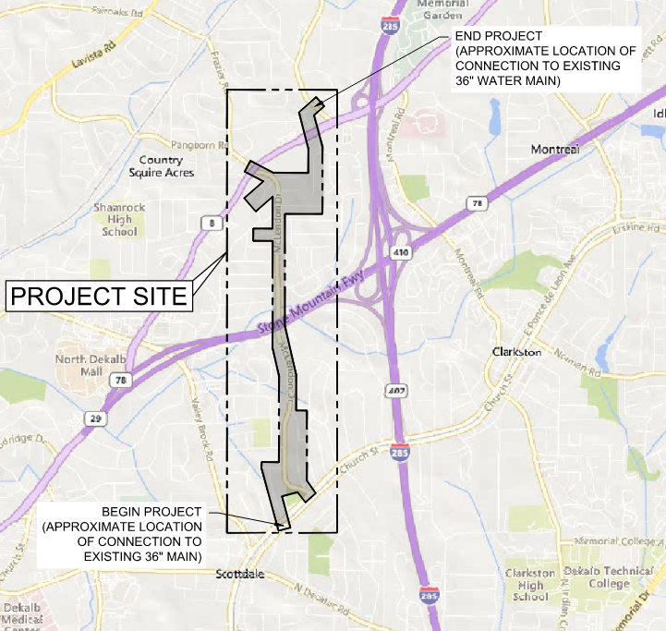

The project takes place in Commissioner Districts 2 and 4.

What’s the Project’s Status?
DeKalb County’s Department of Watershed Management awarded the project to the design engineer, Tetra Tech. Final design work is scheduled to be completed in July 2027. Construction is estimated to begin in 2028 and will last approximately two years.

What’s Next?
- Project Development 2024-2027
- Anticipated Construction Start 2028
- Anticipated Construction Completion 2030

Stay Connected
All current project layouts and alignments are subject to change so check back to the project website for updates.
Click here to view the Project's Website
Scan the QR code for mobile view of the Project’s Website:



DWM Project Information Hotline at 1-800-986-1108 Monday through Friday, from 8:30 a.m. to 5:00 p.m., or email: projectinfo@dekalbcountyga.gov.
DeKalb County Government Facility | 180 Sams Street Decatur, GA 30030

